Ideation Phase
Define the Problem Statements
Date | 8 March 2026
Team ID | AVK103
Project Name | Avi-Luxe E-commerce Application
Maximum Marks | 2 Marks

Customer Problem Statement Template
Create a problem statement to understand your customer's point of view. The Customer Problem Statement template helps you focus on what matters to create experiences people will love.
A well-articulated customer problem statement allows you and your team to find the ideal solution for the challenges your customers face. Throughout the process, you'll also be able to empathize with your customers, which helps you better understand how they perceive your product or service.
Reference: https://miro.com/templates/customer-problem-statement/

Framework Structure
Each problem statement is composed of five structured components that together capture the full customer experience:

Component | Meaning | Guidance
I am  (Customer) | Describe the customer with 3–4 key characteristics: who are they? | Describe the customer and their attributes — role, demographic, context, and motivation
I'm trying to | List their outcome or 'job' — the core thing they are trying to achieve | The goal, task, or job-to-be-done from the customer's perspective
but | Describe what problems or barriers stand in the way — what bothers them most? | The pain point, friction, or obstacle that prevents the customer from achieving their goal
because | Enter the 'root cause' — why does the problem or barrier exist? What needs to be solved? | The underlying reason or gap in the system/product that causes the problem to exist
which makes  me feel | Describe the emotions from the customer's point of view — how does it impact them emotionally? | The emotional consequence: frustrated, anxious, distrustful, disappointed, impatient, etc.

Problem Statement Diagram — All 8 Statements (Visual Overview)
The diagram below presents all 8 customer problem statements in a colour-coded visual grid. Each row corresponds to one persona (PS-1 through PS-8), with columns representing the five framework components:

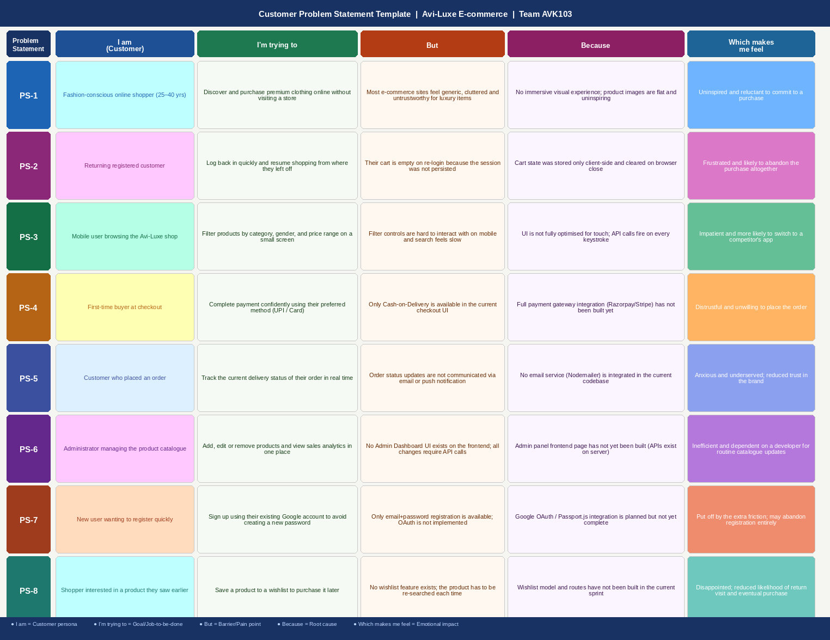

Problem Statements Table — Avi-Luxe E-commerce Application
The following table formalises all 8 customer problem statements based on the actual Avi-Luxe codebase, user research, and identified product gaps:

Problem Statement | I am (Customer) | I'm trying to | But | Because | Which makes me feel
PS-1 | Fashion-conscious online shopper (25–40 yrs) who expects a premium, curated buying experience | Discover and purchase luxury clothing and accessories online without needing to visit a store | Most e-commerce sites feel generic, cluttered, and untrustworthy for high-value fashion purchases | The site lacks an immersive visual experience — product images are flat and there is no luxury brand differentiation | Uninspired and reluctant to commit to a purchase; likely to browse but not convert
PS-2 | Returning registered customer who has shopped on the platform before | Log back in quickly and resume shopping from exactly where they left off — including their cart | Their shopping cart is completely empty upon re-login, even though they had added items in a previous session | Cart state was previously stored only in client-side browser state and was cleared when the browser session ended | Frustrated and likely to abandon the repurchase journey altogether
PS-3 | Mobile user actively browsing the Avi-Luxe shop on a smartphone (iOS or Android) | Quickly filter products by category, gender, and price range to find what they want on a small screen | Filter controls are difficult to interact with on mobile and the search results feel sluggish | The UI was not fully optimised for touch input and API calls fire on every keystroke without a debounce delay | Impatient and more likely to switch to a competitor's more responsive mobile app
PS-4 | First-time buyer who has found items they want and is ready to check out | Complete their purchase confidently using their preferred payment method — UPI, Card, or NetBanking | Only Cash-on-Delivery is available in the checkout UI; digital payment methods are not present | Full payment gateway integration (Razorpay / Stripe) has not been implemented in the current sprint | Distrustful of the platform and unwilling to share delivery address without a secure digital payment option
PS-5 | Customer who has successfully placed an order and is waiting for delivery | Track the current delivery status of their order and receive updates at each stage of fulfilment | No email or push notification is sent at any order status change (confirmed, shipped, delivered) | No email service (Nodemailer / SendGrid) has been integrated into the current codebase | Anxious and underserved; reduced confidence in the brand's reliability and professionalism
PS-6 | Administrator responsible for managing the Avi-Luxe product catalogue and fulfilment operations | Add, update, or remove products and view revenue analytics and order summaries in one visual interface | No Admin Dashboard UI exists on the frontend; all catalogue changes require direct API calls via Postman or curl | The Admin Panel frontend page has not yet been built — the server APIs exist but lack a visual interface | Inefficient and dependent on a developer for every routine catalogue or order management task
PS-7 | New user who wants to sign up quickly using an account they already trust | Register on the Avi-Luxe platform using their existing Google account to avoid creating yet another password | Only email + password registration is supported; there is no OAuth or social login option | Google OAuth (Passport.js) integration is planned but has not yet been completed in the codebase | Put off by the additional registration friction; may abandon the sign-up entirely
PS-8 | Browsing shopper who has discovered an item they like but is not ready to buy immediately | Save a product to a personal wishlist so they can easily find and purchase it in a future session | No wishlist functionality exists — the product must be manually searched again on every return visit | A Wishlist model, routes, and UI have not been built in the current sprint roadmap | Disappointed by the lack of a basic convenience feature; reduced likelihood of returning to complete the purchase

Written Problem Statements
The following section presents each problem statement in full narrative form, combining all five components into a single readable statement. This format is useful for stakeholder presentations and design sprint facilitation.

PS-1 — Premium Shopper Experience
Statement: I am a fashion-conscious online shopper (25–40 years old) who expects a premium, curated buying experience. I'm trying to discover and purchase luxury clothing and accessories online without needing to visit a store. But most e-commerce platforms feel generic, cluttered, and untrustworthy for high-value fashion purchases. Because the site lacks an immersive visual experience — product images are flat and there is no luxury brand differentiation. Which makes me feel uninspired and reluctant to commit to a purchase.
Resolution: Avi-Luxe addresses this through GSAP animations, a Three.js 3D hero scene, a dark luxury UI theme, and high-quality carousel product images.

PS-2 — Cart Persistence Across Sessions
Statement: I am a returning registered customer who has shopped on the platform before. I'm trying to log back in quickly and resume shopping from exactly where I left off — including my cart. But my shopping cart is completely empty upon re-login, even though I had added items in a previous session. Because cart state was previously stored only in client-side browser state and was cleared when the browser session ended. Which makes me feel frustrated and likely to abandon the repurchase journey altogether.
Resolution: Solved in Sprint 1: Cart is persisted in MongoDB (cartRoutes + Cart model) and re-fetched via useCart() on every login.

PS-3 — Mobile Browsing & Search Performance
Statement: I am a mobile user actively browsing the Avi-Luxe shop on a smartphone. I'm trying to quickly filter products by category, gender, and price range to find what I want on a small screen. But filter controls are difficult to interact with on mobile and the search results feel sluggish. Because the UI was not fully optimised for touch input and API calls fire on every keystroke without a debounce delay. Which makes me feel impatient and more likely to switch to a competitor's app.
Resolution: Addressed with mobile-responsive layout and a 350ms debounce on the ShopPage search input.

PS-4 — Payment Method Availability
Statement: I am a first-time buyer who has found items I want and am ready to check out. I'm trying to complete my purchase using my preferred payment method — UPI, Card, or NetBanking. But only Cash-on-Delivery is available in the checkout UI; digital payment methods are not present. Because full payment gateway integration (Razorpay / Stripe) has not been implemented in the current sprint. Which makes me feel distrustful and unwilling to share my delivery address without a secure digital payment option.
Resolution: Planned for Sprint 3: Order model already supports cod/card/upi/netbanking enum; Razorpay SDK integration is next.

PS-5 — Order Status Communication
Statement: I am a customer who has successfully placed an order and am waiting for delivery. I'm trying to track the current delivery status of my order and receive updates at each stage of fulfilment. But no email or push notification is sent at any order status change. Because no email service (Nodemailer / SendGrid) has been integrated into the current codebase. Which makes me feel anxious and underserved, with reduced confidence in the brand's reliability.
Resolution: Planned for Sprint 2: Order status pipeline (5 states) is complete; email integration via Nodemailer is the next step.

PS-6 — Admin Dashboard UI
Statement: I am an administrator responsible for managing the Avi-Luxe product catalogue and fulfilment operations. I'm trying to add, update, or remove products and view revenue analytics and order summaries in one visual interface. But no Admin Dashboard UI exists on the frontend — all catalogue changes require direct API calls via Postman or curl. Because the Admin Panel frontend page has not yet been built, even though the server APIs (GET /api/admin/summary, GET/PUT /api/admin/settings) are fully functional. Which makes me feel inefficient and dependent on a developer for every routine task.
Resolution: Planned for Sprint 2: All server-side admin APIs are ready; the AdminPage React component is the missing piece.

PS-7 — Social Login / OAuth
Statement: I am a new user who wants to sign up quickly using an account I already trust. I'm trying to register on the Avi-Luxe platform using my existing Google account to avoid creating yet another password. But only email + password registration is supported; there is no OAuth or social login option. Because Google OAuth (Passport.js) integration is planned but has not yet been completed in the codebase. Which makes me feel put off by the additional registration friction and I may abandon the sign-up entirely.
Resolution: Planned for Sprint 2: Passport.js + passport-google-oauth20 strategy to be added to authRoutes.

PS-8 — Wishlist Feature
Statement: I am a browsing shopper who has discovered an item I like but am not ready to buy immediately. I'm trying to save a product to a personal wishlist so I can easily find and purchase it in a future session. But no wishlist functionality exists — the product must be manually searched again on every return visit. Because a Wishlist model, routes, and UI have not been built in the current sprint roadmap. Which makes me feel disappointed by the lack of a basic convenience feature, with a reduced likelihood of returning to complete the purchase.
Resolution: Planned for Sprint 2: New Wishlist Mongoose model and /api/wishlist routes to be added, with a WishlistPage in the React client.

References
• Miro Customer Problem Statement Template: https://miro.com/templates/customer-problem-statement/
• Nielsen Norman Group — Problem Statements in UX: https://www.nngroup.com/articles/problem-statements/
• Project Repository: https://github.com/AVK103/Avi-Luxe__E-commerce-Application

